CAPSTONE PROJECT REPORT
(Project Term January-May 2023)

(CIPHER LOCK)

DECLARATION
We hereby declare that the project work entitled (“CIPHER LOCK”) is an authentic record of our own work carried out as requirements of Capstone Project for the award of B. Tech degree in Data science (ML and AI) under the guidance of sir . All the information furnished in this capstone project report is based on our own intensive work and is genuine.
Project Group Number:1
Name of Student : ……………………………
Registration Number: ……………………...

(Signature of Student 1)
Date:

CERTIFICATE
This is to certify that the declaration statement made by this group of students is correct to the best of my knowledge and belief. They have completed this Capstone Project under my guidance and supervision. The present work is the result of their original investigation, effort and study. No part of the work has ever been submitted for any other degree at any University. The Capstone Project is fit for the submission and partial fulfillment of the conditions for the award of B. Tech degree in Data Science (ML and AI) .

Signature and Name of the Mentor
ACKNOWLEDGEMENT
ACKNOWLEDGEMENT
We extend our sincere thanks to Lovely School of Computer Science
Engineering which provided the opportunity to fulfil our wish and achieve our
goal.
We are really grateful to Sami Anand sir for providing us with an opportunity
to undertake this project and providing us with all the facilities. We are highly
thankful to sir for his active support, valuable time and advice, whole-hearted
guidance, sincere cooperation and pains-taking involvement during the study
and in completing the assignment of preparing the said project within the time
stipulated.
Lastly, we are thankful to all those, particularly the various friends, who have
been instrumental in creating a proper, healthy and conducive environment
and including new and fresh innovative ideas for us during the project, without
their help, it would have been extremely difficult for us to prepare the project
in a time-bound framework.
ACKNOWLEDGEMENT
We extend our sincere thanks to Lovely School of Computer Science
Engineering which provided the opportunity to fulfil our wish and achieve our
goal.
We are really grateful to Sami Anand sir for providing us with an opportunity
to undertake this project and providing us with all the facilities. We are highly
thankful to sir for his active support, valuable time and advice, whole-hearted
guidance, sincere cooperation and pains-taking involvement during the study
and in completing the assignment of preparing the said project within the time
stipulated.
Lastly, we are thankful to all those, particularly the various friends, who have
been instrumental in creating a proper, healthy and conducive environment
and including new and fresh innovative ideas for us during the project, without
their help, it would have been extremely difficult for us to prepare the project
in a time-bound framework.
I extend our sincere thanks to School of Computer Science Engineering which provided the opportunity to fulfill our wish and achieve our goal. I really grateful sir for providing us with an opportunity to undertake this project and providing us with all the facilities and highly thankful to sir for his active support, valuable time and advice, whole-hearted guidance, sincere cooperation and pains-taking involvement during the study and in completing the assignment of preparing the said project within the time stipulated.
ABSTRACT
The language translation project aims to develop a software or system capable of accurately and efficiently translating text or speech from one language to another. The project involves several stages, including data collection, preprocessing, machine learning modeling, system integration, and user interface design. The system's objective is to promote communication and understanding between people from different linguistic backgrounds, breaking down language barriers and promoting inclusivity. The project's scope includes developing a system that is accurate, efficient, scalable, robust, and user-friendly. The system should support a wide range of languages and be able to handle different sentence structures, idiomatic expressions, and other linguistic nuances. However, several areas of concern need to be addressed, including accuracy, data privacy, bias and fairness, multilingual support, and user experience. The language translation project has the potential to have a significant impact on communication and understanding between people from different linguistic backgrounds, promoting inclusivity and breaking down barriers in a globalized world. By continually improving the accuracy, privacy, fairness, multilingual support, and user experience of the system, we can create a tool that promotes communication and understanding between people from different linguistic backgrounds.
TABLE OF CONTENTS
Inner first page………………………………………………………………………. (i)
Declaration…...……………………………………………………………………...(ii)
Certificate…….…….………………………………………………………………(iii)
Acknowledgement…………………...………………………………………….......(iv)
Abstract……………………………………………………………………………(v)
Table of Contents……………………...…………………………………………(vi)

1. INTRODUCTION 1

1.1. DESCRIPTION OF THE PROJECT

1.2. ABOUT THE TECNOLOGY

1.2.1. PYTHON

1.2.2 PYTHON MODULES

1.2.3 TKINTER

1.2.4 PYBASE64

2. PROFILE OF THE PROBLEM 5

2.1 OBJECTIVE OF THE PROJECT

2.2 SCOPE OF THE PROJECT
3. Project Legacy 6
3.1 Current Status of the project
3.2 Remaining Areas of concern
4. Source Code (where ever applicable) or System Snapshots 7
5.INPUT 9
6.OUTPUT 10
7.BIBLIOGRAPHY 10
8.CONCLUSION 10

2.2. SCOPE OF THE PROJECT 9
3. EXISTING SYSTEM 9
3.1. INTRODUCTION 9
3.2. EXISTING SOFTWARE 10
3.3. DFD FOR PRESENT SYSTEM 10
3.4. NEW IN THE SYSTEM TO BE DEVELOPED 12
4. PROBLEM ANALYSIS 13
4.1. PRODUCT DEFINITION 13
4.2. FEASIBILITY ANALYSIS 13
4.2.1. TECHNICAL FEASIBILITY 14
4.2.2. ECONOMIC FEASIBILITY 15
4.2.3. SCHEDULE FEASIBILITY 15
4.3. PROJECT PLAN 16
5. SOFTWARE REQUIREMENT 17
5.1. INTRODUCTION 17
5.2. GENERAL DESCRIPTION 17
5.3. SPECIFIC REQUIREMENTS 17
5.3.1. HARDWARE SPECIFICATIONS 18
5.3.2. SOFTWARE SPECIFICATIONS 18
6. DESIGN 19
6.1. SYSTEM DESIGN 19
6.2. DESIGN NOTATION 20
6.3. DETAILED DESIGN 21
viii

6.4. FLOWCHARTS 22
6.5. PSEUDO CODE 23
7. TESTING 25
7.1. FUNCTIONAL TESTING 26
7.1.1. FORM TESTING 26
7.1.2. DATABASE TESTING 27
7.1.3. USABILITY TESTING 27
7.1.4. INTERFACE TESTING 28
7.1.5. COMPATIBILITY TESTING 28
7.1.6. PERFORMANCE TESTING 29
7.1.7. STRESS TESTING 29
7.1.8. SECURITY TESTING 29
7.2. STRUCTURAL TESTING 30
7.3. LEVELS OF TESTING 31
7.4. TESTING THE PROJECT 31
8. IMPLEMENTATION 31
8.1. IMPLEMENTATION OF THE PROJECT 31
8.2. POST IMPLEMENTATION 32
8.3. SOFTWARE MAINTENANCE 32
9. PROJECT LEGACY 34
9.1. CURRENT STATUS OF THE PROJECT 34
9.2. REMAINING AREAS OF CONCERN 34
ix

- INTRODUCTION

Encryption and decryption are essential concepts in computer security that are used to protect sensitive information from unauthorized access. Encryption is the process of converting plaintext or clear text into ciphertext or encrypted text, which is unreadable without a key or password. Decryption, on the other hand, is the process of converting the encrypted text back into plaintext.

Encryption algorithms typically use complex mathematical operations to convert the data into ciphertext.

To encrypt data, the plaintext is first processed through an encryption algorithm, along with a secret key or password. The output of this process is ciphertext, which can only be read by someone who possesses the key or password required for decryption. Decryption involves reversing the encryption process, using the same key or password to convert the ciphertext back into plaintext.

Encryption and decryption are widely used in various applications, including online banking, email, file storage, and communication. It is also used in government and military communication to protect sensitive information.

DESCRIPTION OF THE PROJECT

Text encrypter and decrypter tools are widely used to protect sensitive information, such as passwords, credit card numbers, and personal identification information. These tools allow users to encrypt their data using a secret key or password, making it unreadable and unusable by unauthorized users.

One common use of text encryption and decryption is in online communication. Emails, instant messages, and other forms of digital communication can be vulnerable to interception by hackers or other malicious actors. By using encryption to protect these messages, users can ensure that only the intended recipient can access the message.

1.2. ABOUT THE TECNOLOGY

1.2.1. PYTHON

Python is a high-level, interpreted programming language that is widely used for a variety of tasks, including web development, data analysis, scientific computing, artificial intelligence, and more. It was first released in 1991 and has since become one of the most popular programming languages in the world.

Python supports a variety of programming paradigms, including object-oriented, functional, and procedural programming. It also has a large and comprehensive standard library, which includes modules for a wide range of tasks, such as networking, file handling, regular expressions, and more.

Python is an open-source language, which means that it is freely available and can be used and modified by anyone. It can be installed on various platforms, including Windows, Linux, and macOS, and is compatible with a wide range of software and tools.

Python is a versatile and powerful programming language that is widely used in a variety of industries and domains.

1.2.2 PYTHON MODULES
A Python module is a file containing Python definitions and statements. A module can define functions, classes, and variables. A module can also include runnable code. Grouping related code into a module makes the code easier to understand and use. It also makes the code logically organized.

1.2.3 TKINTER
Python offers multiple options for developing GUI (Graphical User Interface). Out of all the GUI methods, tkinter is the most commonly used method. It is a standard Python interface to the Tk GUI toolkit shipped with Python. Python with tkinter is the fastest and easiest way to create the GUI applications. Creating a GUI using tkinter is an easy task.

import tkinter
There are two main methods used which the user needs to remember while creating the Python application with GUI.

i). Tk(screenName=None, baseName=None, className=’Tk’, useTk=1): To create a main window, tkinter offers a method ‘Tk(screenName=None, baseName=None, className=’Tk’, useTk=1)’. To change the name of the window, you can change the className to the desired one. The basic code used to create the main window of the application is:
m=tkinter.Tk() where m is the name of the main window object

ii). mainloop(): There is a method known by the name mainloop() is used when your application is ready to run. mainloop() is an infinite loop used to run the application, wait for an event to occur and process the event as long as the window is not closed.
1.2.4 PYBASE64
It aims to provide a fast base64 implementation for base64 encoding/decoding.

Installation
pip install pybase64

Usage
pybase64 uses the same API as Python base64 “modern interface” (introduced in Python 2.4) for an easy integration.
To get the fastest decoding, it is recommended to use the pybase64.b64decode and validate=True when possible.

2. PROFILE OF THE PROBLEM

2.1 OBJECTIVE OF THE PROJECT
The main objective of an encrypter is to transform a message or data into a coded form that is difficult for unauthorized parties to understand or access. This is achieved through the use of encryption algorithms, which scramble the original message or data using a secret key or password. The resulting encrypted data can only be decrypted and understood by someone who has the key or password to reverse the encryption process.

The main objective of a decrypter is to reverse the encryption process and convert the encrypted data back into its original form. This is done by using the same secret key or password that was used to encrypt the data in the first place. The decrypted data can then be read or processed by authorized parties who have the necessary credentials to access the original message or data.

2.2 SCOPE OF THE PROJECT

i) People can encrypt and decrypt the data easily.
ii) Encrypters and decrypters are commonly used in normal life to protect sensitive information and maintain privacy.
iii) Banks use encryption to secure online banking transactions, protecting customer information such as account numbers, passwords, and personal information.
iv) Email encryption can be used to protect sensitive information such as personal data, financial information, or confidential business data.
v)Passwords are commonly encrypted to protect them from unauthorized access or hacking attempts.
vi) Messaging Apps: Messaging apps often use encryption to protect messages and calls from being intercepted by third parties.

3. Project Legacy
3.1 Current Status of the project
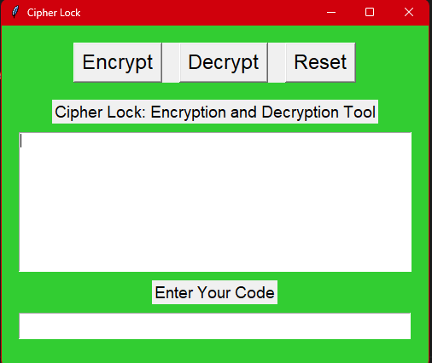
Currently, the project can encrypt and decrypt text.

3.2 Remaining Areas of concern

Remaining Areas of concern
i) In future it can convert text files (like pdf, docx) and images.
ii)Improving user experience: Another area of focus could be to improve the user interface and overall user experience. This could involve simplifying the encryption and decryption process or adding more user-friendly features.

iii)Enhancing security: Security is a crucial aspect of any encryption software. Future development could involve improving the security measures used in the software or adding additional layers of protection against attacks.

iv) Optimizing performance: Another area of focus could be to improve the performance and speed of the software. This could involve optimizing algorithms, improving memory management, or reducing the software's resource usage.
v) Feedback option.

4. Source Code (where ever applicable) or System Snapshots
from tkinter import *
import pybase64
from tkinter import messagebox

root = Tk()
root.title("Cipher Lock")
root.geometry("500x400")
root.config(bg="lime green")

def reset():

my_text.delete(1.0, END)
my_entry.delete(0, END)

def encrypt():

secret = my_text.get(1.0, END)

my_text.delete(1.0, END)

# Logic for password
if my_entry.get() == "123456789":
# Convert to byte
secret = secret.encode("ascii")
# Convert to base64
secret = pybase64.b64encode(secret)
# Convert it back to ascii
secret = secret.decode("ascii")
# Print to text box
my_text.insert(END, secret)

else:
# Flash a message if wrong password
messagebox.showwarning("Incorrect!", "Incorrect Password, Try Again!")

def decrypt():
# Get text from text box
secret = my_text.get(1.0, END)
# Clear the screen
my_text.delete(1.0, END)

# Logic for password
if my_entry.get() == "123456789":
# Convert to byte
secret = secret.encode("ascii")
# Convert to base64
secret = pybase64.b64decode(secret)
# Convert it back to ascii
secret = secret.decode("ascii")
# Print to text box
my_text.insert(END, secret)

else:
# Flash a message if wrong password
messagebox.showwarning("Incorrect!", "Incorrect Password, Try Again!")

my_frame = Frame(root)
my_frame.pack(pady=20)

enc_button = Button(my_frame, text="Encrypt", font=("Helvetica", 18), command=encrypt)
enc_button.grid(row=0, column=0)

dec_button = Button(my_frame, text="Decrypt", font=("Helvetica", 18), command=decrypt)
dec_button.grid(row=0, column=1, padx=20)

reset_button = Button(my_frame, text="Reset", font=("Helvetica", 18), command=reset)
reset_button.grid(row=0, column=2)

enc_label = Label(root, text="Cipher Lock: Encryption and Decryption Tool", font=("Helvetica", 14))
enc_label.pack()

my_text = Text(root, width=57, height=10)
my_text.pack(pady=10)

Code_label = Label(root, text="Enter Your Code", font=("Helvetica", 14))
Code_label.pack()

my_entry = Entry(root, font=("Helvetica", 18), width=35, show="*")
my_entry.pack(pady=10)

root.mainloop()

5.INPUT
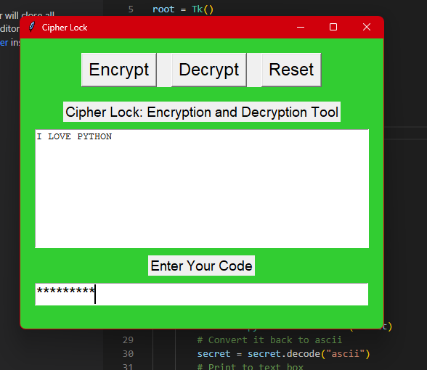
INPUT = I LOVE PYTHON
CODE=123456789
6.OUTPUT
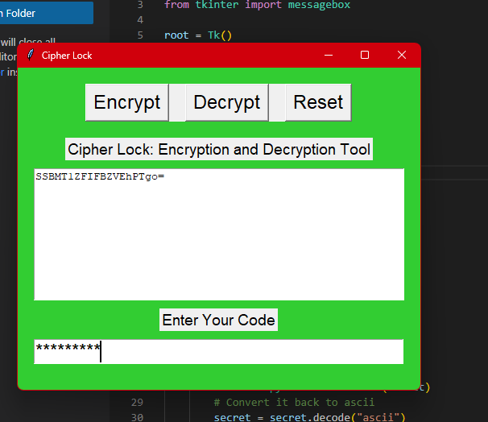
OUTPUT = SSBMT1ZFIFBZVEhPTgo=
CODE =123456789
5. Bibliography
Here are some references for the encrypter and decrypter project:
1)UPGRAD PYTHON MODULE
2)GEEKS FOR GEEKS
3)STACKOVERFLOW
4)CHATGPT
These resources provide a comprehensive overview of the concepts, principles, and techniques involved in the encrypter and decrypter project.

6. CONCLUSION
In conclusion, the encrypter and decrypter project is a crucial software tool that provides a secure way to protect sensitive information. The project involved a feasibility analysis, software requirement analysis, design, and implementation phases to create an effective encryption and decryption software.

Future development of the project can include improving the software's user interface, enhancing security features, optimizing performance.

Overall, the encrypter and decrypter project has the potential to provide a valuable service to individuals and businesses who need to protect sensitive information. By ensuring the software is continually updated and improved, it can remain a reliable tool for secure data encryption and decryption in the future.

